City of Bastrop Inspection Requirements

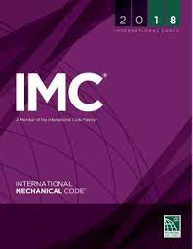

International Mechanical Code (IMC)

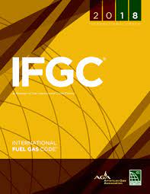

International Fuel Gas Code (IFGC)

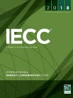

NOTE: The commercial (C) and residential (R) energy code inspections as required by the International Energy Conservation Code (IECC) are incorporated in the IPC inspections listed and are preceded by the letters IECC.

107.2 Required inspections and testing (IMC and IFGC)
Underground inspection shall be made after trenches or ditches are excavated and bedded, piping is installed, and before backfill is put in place. Where excavated soil contains rocks, broken concrete, frozen chunks, and other rubble that would damage or break the piping or cause corrosive action, clean backfill shall be on the job site.
Rough-in inspection shall be made after the roof, framing, fireblocking, and bracing are in place and all ducting and other components to be concealed are complete, and prior to the installation of wall or ceiling membranes.
IECC C105.2.4
Verify the installed HVAC equipment for the correct type and size, controls, insulation, R-values, system and damper air leakage, minimum fan efficiency, energy recovery and economizer as required by code.

IECC R015.2.4
Verify the installed HVAC equipment for the correct type and size, controls, insulation, R-values, system air leakage control, programmable thermostats, dampers, whole-house ventilation, and minimum fan efficiency as required by code.
Final inspection shall be made upon completion of the mechanical system.
IECC C105.2.6
Verification of the installation and proper installation of all required building controls, and documentation verifying activities associated with required building commissioning have been conducted.
The code official is authorized to make or require other inspections of any construction work to ascertain compliance.

City of Bastrop – Inspections

- Mechanical Change Out
- Mechanical Rough
- Mechanical Above Ceiling
- Mechanical Vents Inspection
- Hood Grease Ducts
- Freezer/Cooler Rough
- Mechanical Smoke/Fire Dampers
- Mechanical Final

